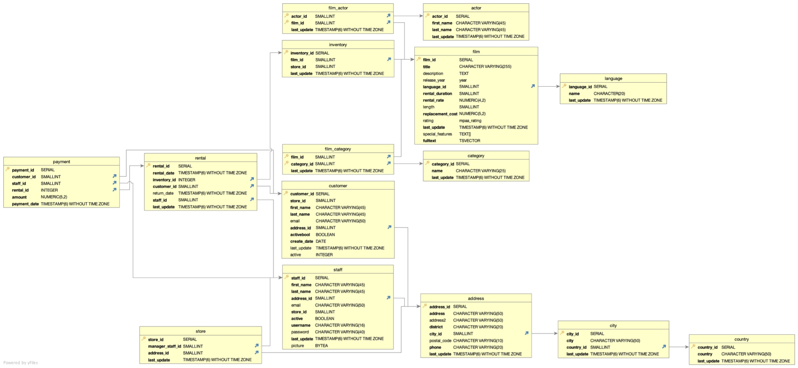

There is a snowflake schema in this database. The fact table, in my opinion, is the rental table. Through the use of the sub dimensions, such as city, country, or actor, the snowflake pattern can be identified.

**Data dictionary:**

Facts:

payment

| **column** | **data type** | **description** |
| --- | --- | --- |
| payment_id | SERIAL | primary key |
| cutomer_id | SMALLINT | customer who had payed (foreign key) |
| staff_id | SMALLINT | employee who accepted the payment (foreign key) |
| rental_id | INTEGER | rentale details (foreign key) |
| amount | NUMBER(5,2) | sum to be paid |
| payment_date | TIMESTAMP(6) WITHOUT TIME ZONE | date till the payment needs to be made |

rental

| **column** | **data type** | **description** |
| --- | --- | --- |
| rentale_id | SERIAL | primary key |
| rentale_date | TIMESTAMP(6) WITHOUT TIME ZONE | Date the film was rented |
| inventory_id | INTEGER | foreign key to inventory table of the rented film |
| customer_id | SMALLINT | customer who rented the film (foreign key) |
| return_date | TIMESTAMP(6) WITHOUT TIME ZONE | Date the film must be returned |
| staff_id | SMALLINT | employee who distributed the film (foreign key) |
| last_update | TIMESTAMP(6) WITHOUT TIME ZONE | time of the last modification |

store

| **column** | **data type** | **description** |
| --- | --- | --- |
| store_id | SERIAL | primary key |
| manager_staff_id | SMALLINT | details about the manager of the store (foreign key) |
| address_id | SMALLINT | details about the address (foreign key) |
| last_update | TIMESTAMP(6) WITHOUT TIME ZONE | time of the last modification |

film_category

| **column** | **data type** | **description** |
| --- | --- | --- |
| film_id | SMALLINT | composite and foreign key to film table |
| category_id | SMALLINT | composite and foreign key to category table |
| last_update | TIMESTAMP(6) WITHOUT TIME ZONE | time of the last modification |

film_actor

| **column** | **data type** | **description** |
| --- | --- | --- |
| actor_id | SMALLINT | composite and foreign key to actor table |
| film_id | SMALLINT | composite and foreign key to film table |
| last_update | TIMESTAMP(6) WITHOUT TIME ZONE | time of the last modification |

inventory

| **column** | **data type** | **description** |
| --- | --- | --- |
| inventory_id | SERIAL | primary key |
| film_id | SMALLINT | details about the rented film (foreign key) |
| store_id | SMALLINT | details about the store the film was rented in (foreign key) |
| last_update | TIMESTAMP(6) WITHOUT TIME ZONE | time of the last modification |

Dimensions:

actor

| **column** | **data type** | **description** |
| --- | --- | --- |
| actor_id | SERIAL | primary key |
| first_name | CHARACTER VARYING(45) | the first name of the actor |
| last_name | CHARACTER VARYING(45) | the last name of the actor |
| last_update | TIMESTAMP(6) WITHOUT TIME ZONE | time of the last modification |

film

| **column** | **data type** | **description** |
| --- | --- | --- |
| film_id | SERIAL | primary key |
| title | CHARACTER VARYING(255) | the title of the film |
| description | TEXT | the description of the film |
| release_year | year | the year the film was released |
| language_id | SMALLINT | language in which the film was shot |
| rental_duration | SMALLINT | the length the movie was rented(average??) |
| rental_rate | NUMERIC(4,2) | rental rate of the movie (per year??) |
| length | SMALLINT | length of the movie in minutes |
| replacement_cost | NUMERIC(5,2) | price to be paid if the film needs to be replaced |
| rating | mpaa_rating | mpaa rating ([More info](https://www.mtsu.edu/first-amendment/article/1247/motion-picture-ratings)) |
| last_update | TIMESTAMP(6) WITHOUT TIME ZONE | time of the last modification |
| special_feature | Text[] | extra movie scenes/specials |
| fulltext | TSVECTOR | looks like some sort of categorizing to me |

language

| **column** | **data type** | **description** |
| --- | --- | --- |
| language_id | SERIAL | primary key |
| name | CHARACTER(20) | language name |
| last_update | TIMESTAMP(6) WITHOUT TIME ZONE | time of the last modification |

category

| **column** | **data type** | **description** |
| --- | --- | --- |
| category_id | SERIAL | primary key |
| name | CHARACTER VARYING(25) | category name |
| last_update | TIMESTAMP(6) WITHOUT TIME ZONE | time of the last modification |

customer

| **column** | **data type** | **description** |
| --- | --- | --- |
| customer_id | SERIAL | primary key |
| store_id | SMALLINT | details about the store the customer created this account (foreign key) |
| first_name | CHARACTER VARYING(45) | Customer’s first name |
| last_name | CHARACTER VARYING(45) | Customer's last name |
| email | CHARACTER VARYING(50) | Customer’s email address |
| adress_id | SMALLINT | Customer’s address details (foreign key) |
| activebool | BOOLEAN | bool if customer is active |
| create_date | DATE | time where customer creates this account |
| last_update | TIMESTAMP(6) WITHOUT TIME ZONE | time of the last modification |
| active | INTEGER | bool in the form of an integer(no direct connection to activebool) |

staff

| **column** | **data type** | **description** |
| --- | --- | --- |
| customer_id | SERIAL | primary key |
| first_name | CHARACTER VARYING(45) | Staff’s first name |
| last_name | CHARACTER VARYING(45) | Staff’s last name |
| adress_id | SMALLINT | Staff’s address details (foreign key) |
| email | CHARACTER VARYING(50) | Staff’s email address |
| store_id | SMALLINT | details about the store the staff works in (foreign key) |
| active | BOOLEAN | bool if staff is active |
| username | CHARACTER VARYING(16) | Employee’s username |
| password | CHARACTER VARYING(40) | Password for the employee's username |
| last_update | TIMESTAMP(6) WITHOUT TIME ZONE | time of the last modification |
| picture | BYTEA | Employee’s picture |

address

| **column** | **data type** | **description** |
| --- | --- | --- |
| address_id | SERIAL | primary key |
| address | CHARACTER VARYING(50) | Employee’s address |
| address2 | CHARACTER VARYING(50) | Employee’s second address (not required) |
| district | CHARACTER VARYING(20) | Employee’s district |
| city_id | SMALLINT | details about Employee’s city (foreign key) |
| postal_code | CHARACTER VARYING(10) | Employee’s postal code |
| phone | CHARACTER VARYING(20) | Employee’s phone number |
| last_update | TIMESTAMP(6) WITHOUT TIME ZONE | time of the last modification |

city

| **column** | **data type** | **description** |
| --- | --- | --- |
| city_id | SERIAL | primary key |
| city | CHARACTER VARYING(50) | name of the city |
| country_id | SMALLINT | details about the country (foreign key) |
| last_update | TIMESTAMP(6) WITHOUT TIME ZONE | time of the last modification |

country

| **column** | **data type** | **description** |
| --- | --- | --- |
| country_id | SERIAL | primary key |
| country | CHARACTER VARYING(50) | name of the country |
| last_update | TIMESTAMP(6) WITHOUT TIME ZONE | time of the last modification |

**Step 4**

* We would need the **payment** table to get the amount of revenue. Then we need the tables to get the name of the actor: **rental**, **inventory**, **film_actor** and **actor**.
* We can easily use the **film** **table** since we require all movies. In order to determine which number belongs to which table while counting them by language, we also need the **language** **table** therefore.